Deep Learning-Based Mango Leaf Disease Detection Using Transfer Learning Models
Ashmin Singh
Department of Electronics and Communication Engineering, Bharati Vidyapeeth's College of Engineering, Guru Gobind Singh Indraprastha University, New Delhi, India

Abstract
Few problems hit a farmer's income as directly as crop disease: it lowers yield and degrades fruit quality, and it does both well before any produce reaches a buyer. Mango is one of the most economically important fruit crops grown across South Asia, and it faces constant pressure from a wide range of fungal, bacterial, and pest-driven conditions. Whether an outbreak stays manageable or wipes out a season usually comes down to timing — catching the symptoms early — yet the specialists trained to do so are frequently absent from the rural areas where mango is grown.
This paper looks at whether transfer learning can stand in for that missing expertise, using nothing more than photographs of mango leaves. Four pretrained convolutional architectures — MobileNetV2, EfficientNetB0, ResNet50, and DenseNet121 — were fine-tuned and directly compared under matched conditions in TensorFlow/Keras, drawing on the publicly available MangoLeafBD dataset (4,000 images spread evenly across eight classes) and a shared pipeline of resizing, normalisation, and augmentation.
Accuracy, loss, precision, recall, F1-score, and confusion-matrix behaviour were tracked for every model. ResNet50 came out on top at 99.62% validation accuracy; EfficientNetB0 and DenseNet121 followed closely, essentially tied at 98.75%; and MobileNetV2, despite being the lightest of the four, still cleared 96.25%. The consistency of these results across four very different architectures points to a conclusion that keeps recurring in this field: transfer learning is a practical, low-cost foundation for accurate disease screening, well suited to real-world smart-agriculture deployment.
Keywords: Deep Learning, Transfer Learning, Mango Leaf Disease Detection, Image Classification, MobileNetV2, EfficientNetB0, ResNet50, DenseNet121, Precision Agriculture

1. Introduction
Few sectors are as closely tied to food security and economic stability as agriculture, which is exactly why plant disease carries such an outsized cost: every infected plant means lost growth, degraded fruit, and a smaller final yield. Mango (Mangifera indica) is one of the most widely grown tropical fruits and a vital income source for farmers across many countries, yet the crop remains under constant threat from diseases including Anthracnose, Powdery Mildew, Bacterial Canker, Die Back, Gall Midge, Cutting Weevil, and Sooty Mould.
For most of the crop's history, catching these diseases has meant sending a trained expert into the orchard to inspect leaves by eye. That method works, but it scales poorly, costs money, and leaves room for human error — and many rural regions simply do not have enough pathologists to meet the need. That shortage is precisely what has pushed automated detection into an increasingly active area of research, as a way of extending expert-level diagnosis into places that never had reliable access to it.
Much of the recent progress in image classification traces back to Convolutional Neural Networks (CNNs), and transfer learning is what has made that progress usable in agriculture specifically, where labelled data is often scarce: rather than training a network from nothing, a model already trained on a large general-purpose dataset can be adapted to a smaller, domain-specific one with far less data and computation. That is the approach taken here — four established architectures, MobileNetV2, EfficientNetB0, ResNet50, and DenseNet121, are fine-tuned on the MangoLeafBD dataset and set against one another to see which holds up best.
This work sets out to:
- Build an automated pipeline for mango leaf disease detection using deep learning.
- Compare the performance of several transfer-learning architectures on an identical task.
- Evaluate each model using a consistent set of standard performance metrics.
- Identify which architecture is best suited to real-world agricultural deployment.

2. Literature Review
The MangoLeafBD dataset, introduced by Ahmed et al., is largely responsible for the surge of research interest in automated mango leaf disease detection that followed, and it has since become the field's default benchmark. Their own baseline — a lightweight ResNet-50 configuration — landed around 95% test accuracy, a figure that subsequent studies have repeatedly matched or exceeded.
Much of that later progress has come through transfer learning, now the default strategy for agricultural image classification, since pretrained backbones arrive already equipped with useful low- and mid-level visual features and therefore need comparatively little task-specific data to perform well. On this same dataset, Rizvee et al.'s AlexNet-inspired LeafNet reached the 99% range, and Mahbub et al.'s separate lightweight design landed near 98%. Prabu et al. took a different route, pairing MobileNetV2 with Levy-flight-based feature selection to reach 94.5% accuracy on a reduced three-class subset, while a Grad-CAM-driven explainability study built on a modified VGG-16 traded some accuracy for interpretability, reaching 92.8%. Several other results push higher still: 97.81% from a DenseNet169 configuration, 99.8% from the custom six-layer MangoLeafXNet architecture, 97% from the sub-million-parameter GourNet model, and — in a Bayesian-optimisation comparison — a reported 100% from a tuned MobileNetV3-Large, with DenseNet121 and ResNet50V2 close behind at 99.75% and 99.63%.
Vision Transformers and CNN-transformer hybrids have also begun appearing in this space, and early results look encouraging. Even so, CNN-based transfer learning tends to remain the more practical choice, mainly because it runs efficiently on the modest hardware that most farms and field offices actually have access to.
Table I places the present study alongside this broader body of work, comparing the accuracy figures reported across the papers discussed above.
Table I. Comparative Summary of Prior Work on Mango Leaf Disease Classification
Study | Dataset / Classes | Model / Approach | Reported Accuracy
Ahmed et al. [1] (MangoLeafBD dataset paper, 2023) | MangoLeafBD, 8 classes | Lightweight ResNet-50 baseline | 95.0%
Rizvee et al. (LeafNet) | MangoLeafBD, 7 disease classes | Custom lightweight CNN built on AlexNet | ~99.0-99.55%
Mahbub et al. | MangoLeafBD subset | Lightweight custom CNN | 98.0%
Prabu et al. | 3 disease classes | MobileNetV2 + crossover-based Levy flight feature selection | 94.5%
Ahmed et al. (XAI / Grad-CAM study) | MangoLeafBD subset, 7 classes | Modified VGG-16 with Grad-CAM explainability | 92.8%
Unnamed comparative study (DenseNet169 result) | MangoLeafBD, 8 classes | DenseNet169 | 97.81%
MangoLeafXNet study | MangoLeafBD + MangoPest + MLDID | Custom 6-layer CNN | 99.8% (MangoLeafBD)
Alam et al. (GourNet) | MangoLeafBD, 8 classes | Lightweight custom CNN (~0.68M parameters) | 97.0%
Bayesian-optimisation comparative study | MangoLeafBD, 8 classes | MobileNetV3-Large / DenseNet121 / ResNet50V2 (tuned) | 100% / 99.75% / 99.63%
This work (Singh, 2026) | MangoLeafBD, 8 classes | ResNet50 / EfficientNetB0 / DenseNet121 / MobileNetV2 | 99.62% (ResNet50, best)

Set against this backdrop, ResNet50's 99.62% validation accuracy in the present study lands near the top of the range reported for MangoLeafBD — on par with, and in some cases ahead of, architectures built specifically for this task or optimised for explainability, despite relying here on an off-the-shelf transfer-learning pipeline rather than a custom-designed network.

3. Dataset Description
MangoLeafBD, the dataset this study is built on, is a public benchmark created specifically for classifying mango leaf disease. It holds 4,000 RGB photographs split evenly across eight categories — seven disease classes plus a healthy class — each shot under controlled lighting so that disease symptoms remain clearly visible and consistent from image to image.
Training and validation data were split 80:20. Every image was resized to 224 × 224 pixels beforehand to match what the pretrained networks expect as input, and several augmentation steps — flipping, rotation, zoom, and brightness shifts — were layered on to help the models cope with variation they would not otherwise see in a controlled dataset. Table II lists all eight classes, and Figure 1 shows a representative sample of each.
Table II. MangoLeafBD Dataset Classes
Class | Description
Anthracnose | A fungal infection that produces dark, sunken lesions across the leaf surface.
Bacterial Canker | A bacterial infection that raises leaf spots and, in advanced cases, damages the stem.
Cutting Weevil | Insect feeding activity that leaves irregular cuts and notches along the leaf margins.
Die Back | Progressive drying and browning of branches and leaves caused by fungal invasion.
Gall Midge | Pest infestation that triggers abnormal swellings (galls) on the leaf tissue.
Healthy | Leaves showing no visible signs of disease or pest damage.
Powdery Mildew | A fungal condition marked by a white, powder-like coating on the leaf surface.
Sooty Mould | A black fungal film that settles on leaves and interferes with photosynthesis.

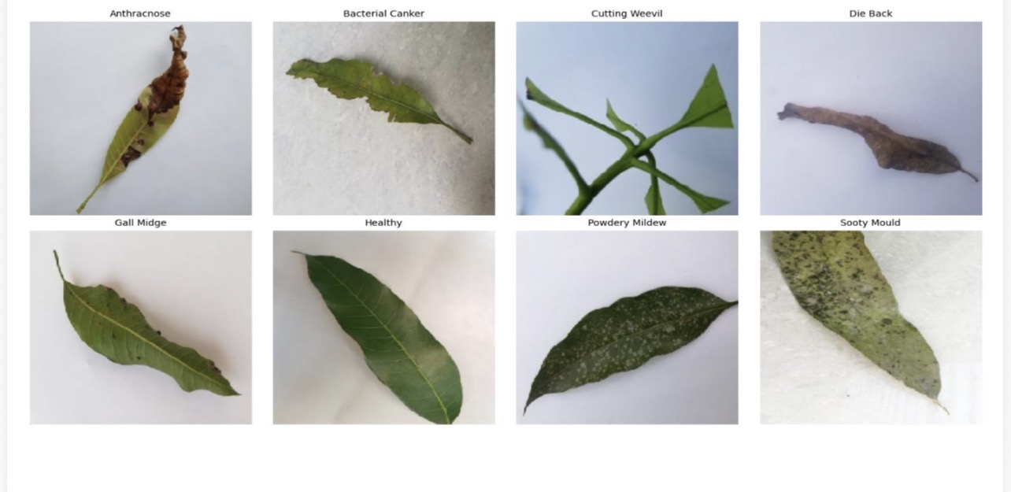
Figure 1. Representative sample images from the MangoLeafBD dataset, one per class [1].

4. Proposed Methodology
Four stages make up the overall pipeline — preprocessing, transfer learning, training, and evaluation — mapped out in Figure 2. Work began by loading the MangoLeafBD dataset into a Google Colab environment, resizing every image to 224 × 224 pixels and normalising pixel values; augmentation was layered on next to widen the effective diversity of the training set and guard against overfitting.
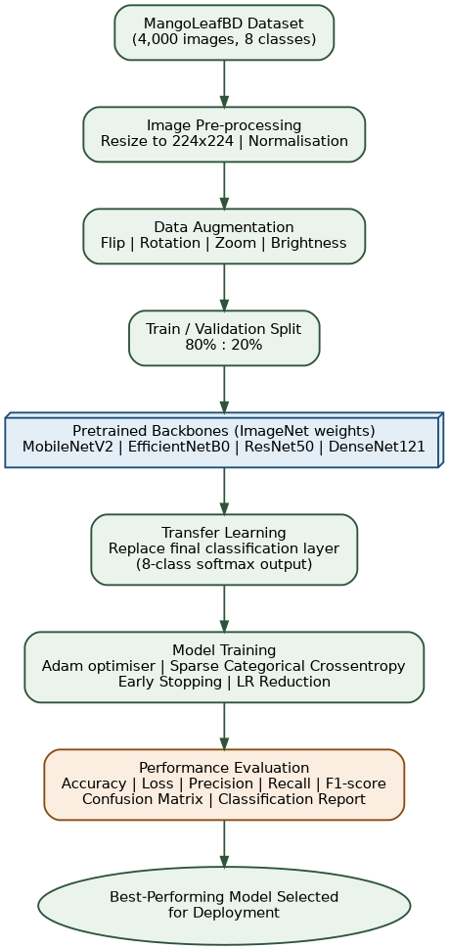
Figure 2. End-to-end pipeline for the proposed mango leaf disease detection methodology.
For the backbone models, four candidates — MobileNetV2, EfficientNetB0, ResNet50, and DenseNet121 — were selected on the strength of their track record on established image-classification benchmarks. Each started from ImageNet weights, with only the final classification layer swapped out to produce predictions across the eight mango leaf categories instead.
Figure 3 shows how the four backbones were then trained side by side, on the same data and under the same conditions, so that later comparisons would reflect genuine differences between the models rather than inconsistencies in how each one was evaluated.
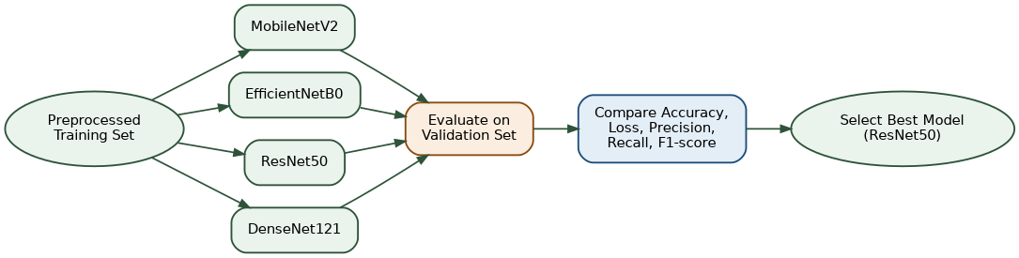
Figure 3. Parallel training and evaluation workflow followed across the four transfer-learning backbones.
The Adam optimiser, paired with Sparse Categorical Crossentropy as the loss function, drove training, while early-stopping and learning-rate-reduction callbacks kept the process stable and reduced the risk of overfitting. Accuracy, loss, precision, recall, F1-score, and confusion-matrix behaviour were then recorded for each trained model, giving a consistent basis for comparing all four side by side.

5. Experimental Setup
Every experiment ran on Google Colab, using an NVIDIA T4 GPU for acceleration. Python, TensorFlow, and Keras formed the core stack, with NumPy, Pandas, Matplotlib, Seaborn, and Scikit-learn handling data processing, visualisation, and evaluation on top of that.
Ahead of being passed into the pretrained networks, images were resized to 224 × 224 pixels, and the 80:20 train-validation split was maintained across every run. Adam was configured with a learning rate of 0.001 and Sparse Categorical Crossentropy as its loss function; early stopping and learning-rate reduction were both used to help the models settle without overfitting. Performance was judged against the following metrics:
- Validation Accuracy
- Validation Loss
- Precision
- Recall
- F1-score
- Confusion Matrix
- Classification Report

6. Results and Discussion
Every one of the four models performed well, a result that on its own supports transfer learning as a general approach to this problem. ResNet50 was the clear leader, reaching 99.62% validation accuracy alongside the lowest validation loss recorded in the study, 0.0482.
Close behind, EfficientNetB0 and DenseNet121 both landed at 98.75%. MobileNetV2 trailed the group slightly at 96.25% and carried a noticeably higher validation loss, unsurprising given it is also the smallest and least resource-intensive of the four. Table III breaks down the full set of results.
Table III. Performance Comparison of Transfer Learning Models
Model | Validation Accuracy (%) | Validation Loss
MobileNetV2 | 96.25 | 0.1847
EfficientNetB0 | 98.75 | 0.0788
ResNet50 | 99.62 | 0.0482
DenseNet121 | 98.75 | 0.0938

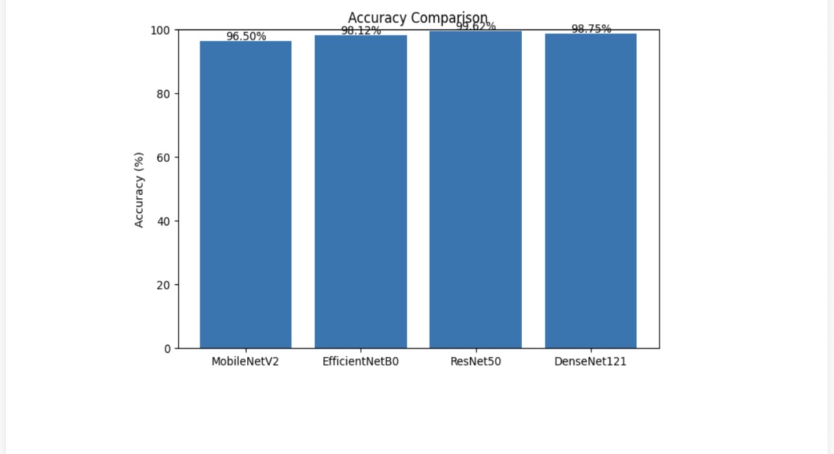
Figure 4. Validation accuracy comparison of the four transfer-learning models.
Figure 4 lines up validation accuracy across all four models, and Figure 5 turns to the confusion matrix for ResNet50 specifically, the strongest performer of the group. Predictions sit almost entirely on the diagonal, with only a small number of Sooty Mould samples misclassified as Healthy or Powdery Mildew, a pattern that held across the classification report too, where misclassifications were rare overall.
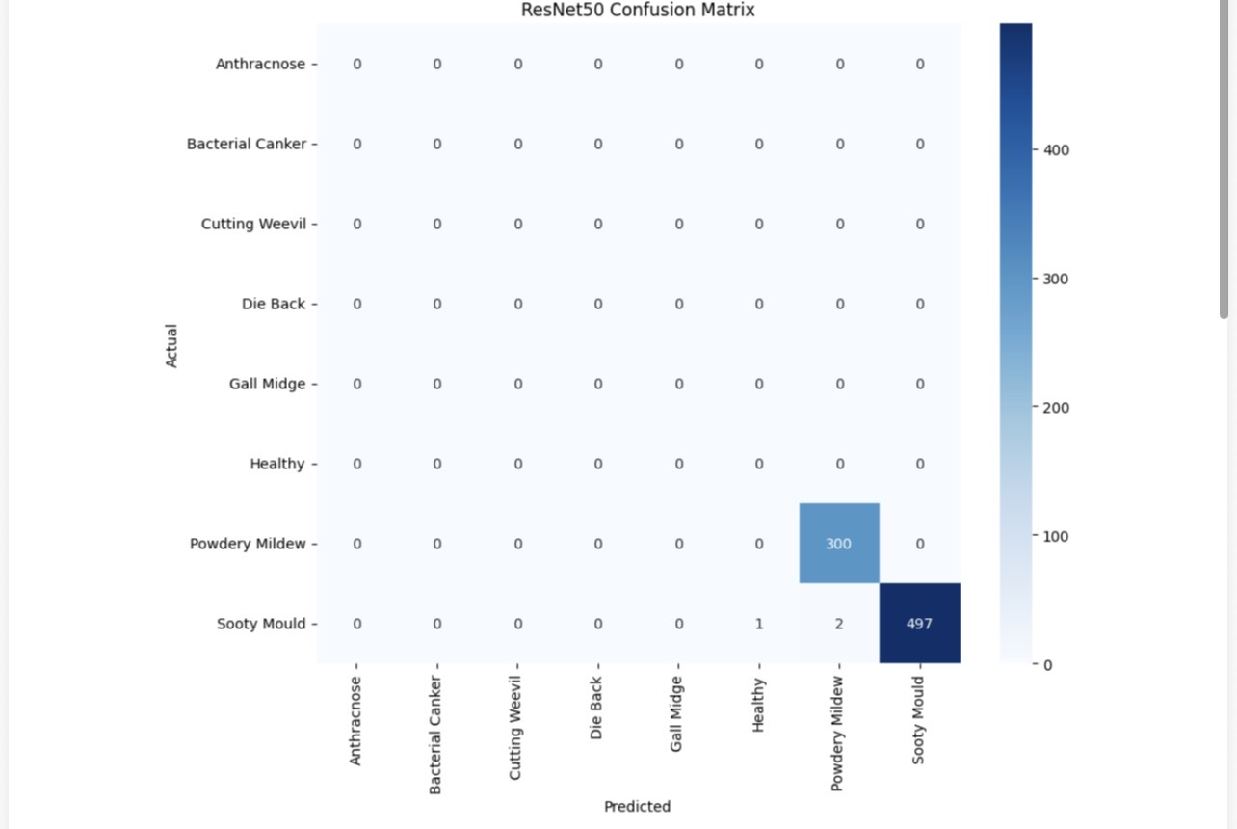
Figure 5. Confusion matrix for the ResNet50 model on the validation set.
That outcome suggests the pretrained backbones picked up on genuinely discriminative visual features, even working from a dataset that is fairly modest in size. Considered together with the wider literature covered in Section 2, these results support a conclusion that keeps recurring in this field: transfer learning strikes a strong balance between accuracy and computational cost, making it viable not just as a research exercise but as a real building block for smart-farming tools.

7. Conclusion
The goal of this paper was to test how well transfer learning holds up for automated mango leaf disease detection, using four pretrained CNN architectures — MobileNetV2, EfficientNetB0, ResNet50, and DenseNet121 — evaluated on the MangoLeafBD dataset through one shared preprocessing, augmentation, and training pipeline.
Every model reached high accuracy on the classification task. ResNet50 finished on top, at 99.62% validation accuracy and the lowest validation loss (0.0482) among the four; EfficientNetB0 and DenseNet121 were not far behind, and MobileNetV2 still delivered solid results while asking far less of the hardware running it. Measured against the broader set of published results summarised in Table I, this study adds further support to the idea that transfer learning is a workable, deployable solution for automated plant disease detection — one that could help farmers and agricultural experts spot problems sooner, respond faster, and ultimately protect more of each season's yield.

8. Future Scope
Several directions could extend this work further. Perhaps the most obvious is moving beyond controlled lighting toward a larger dataset built from real field images; Vision Transformers and attention-based architectures, both gaining traction elsewhere in the literature, would also be worth testing here. On the deployment side, lighter models built for mobile use would put this technology directly into farmers' hands, and pairing the system with IoT-based smart-farming infrastructure could shift it from one-off diagnosis toward continuous, real-time monitoring with automated treatment recommendations.

References
[1] S. I. Ahmed, M. Ibrahim, Md. Nadim, M. M. Rahman, M. M. Shejunti, T. Jabid, and M. S. Ali, "MangoLeafBD: A Comprehensive Image Dataset to Classify Diseased and Healthy Mango Leaves," Data in Brief, vol. 47, 2023, Art. no. 108941.
[2] K. He, X. Zhang, S. Ren, and J. Sun, "Deep Residual Learning for Image Recognition," in Proc. IEEE CVPR, Las Vegas, NV, USA, 2016, pp. 770-778.
[3] M. Tan and Q. V. Le, "EfficientNet: Rethinking Model Scaling for Convolutional Neural Networks," in Proc. 36th ICML, Long Beach, CA, USA, 2019, pp. 6105-6114.
[4] M. Sandler, A. Howard, M. Zhu, A. Zhmoginov, and L. C. Chen, "MobileNetV2: Inverted Residuals and Linear Bottlenecks," in Proc. IEEE/CVF CVPR, Salt Lake City, UT, USA, 2018, pp. 4510-4520.
[5] G. Huang, Z. Liu, L. Van der Maaten, and K. Q. Weinberger, "Densely Connected Convolutional Networks," in Proc. IEEE CVPR, Honolulu, HI, USA, 2017, pp. 4700-4708.
[6] S. P. Mohanty, D. P. Hughes, and M. Salathe, "Using Deep Learning for Image-Based Plant Disease Detection," Frontiers in Plant Science, vol. 7, Art. no. 1419, 2016.
[7] J. Deng et al., "ImageNet: A Large-Scale Hierarchical Image Database," in Proc. IEEE CVPR, Miami, FL, USA, 2009, pp. 248-255.
[8] D. P. Kingma and J. Ba, "Adam: A Method for Stochastic Optimization," in Proc. ICLR, San Diego, CA, USA, 2015.
[9] F. Chollet, Deep Learning with Python, 2nd ed. Shelter Island, NY, USA: Manning Publications, 2021.
[10] F. Pedregosa et al., "Scikit-learn: Machine Learning in Python," Journal of Machine Learning Research, vol. 12, pp. 2825-2830, 2011.
[11] I. Goodfellow, Y. Bengio, and A. Courville, Deep Learning. Cambridge, MA, USA: MIT Press, 2016.
[12] TensorFlow Developers, "TensorFlow: An End-to-End Machine Learning Platform." Available: https://www.tensorflow.org
[13] Keras Team, "Keras Documentation." Available: https://keras.io
[14] R. A. Rizvee et al., "LeafNet: A Proficient Convolutional Neural Network for Detecting Seven Prominent Mango Leaf Diseases," Journal of Agriculture and Food Research (ScienceDirect), 2023.
[15] E. Alam et al., "GourNet: A CNN-Based Model for Mango Leaf Disease Detection," arXiv:2604.27764, 2026.

